**Online Survey Management**

**Final Outputs Documentation:**  
  
1.User Registration:

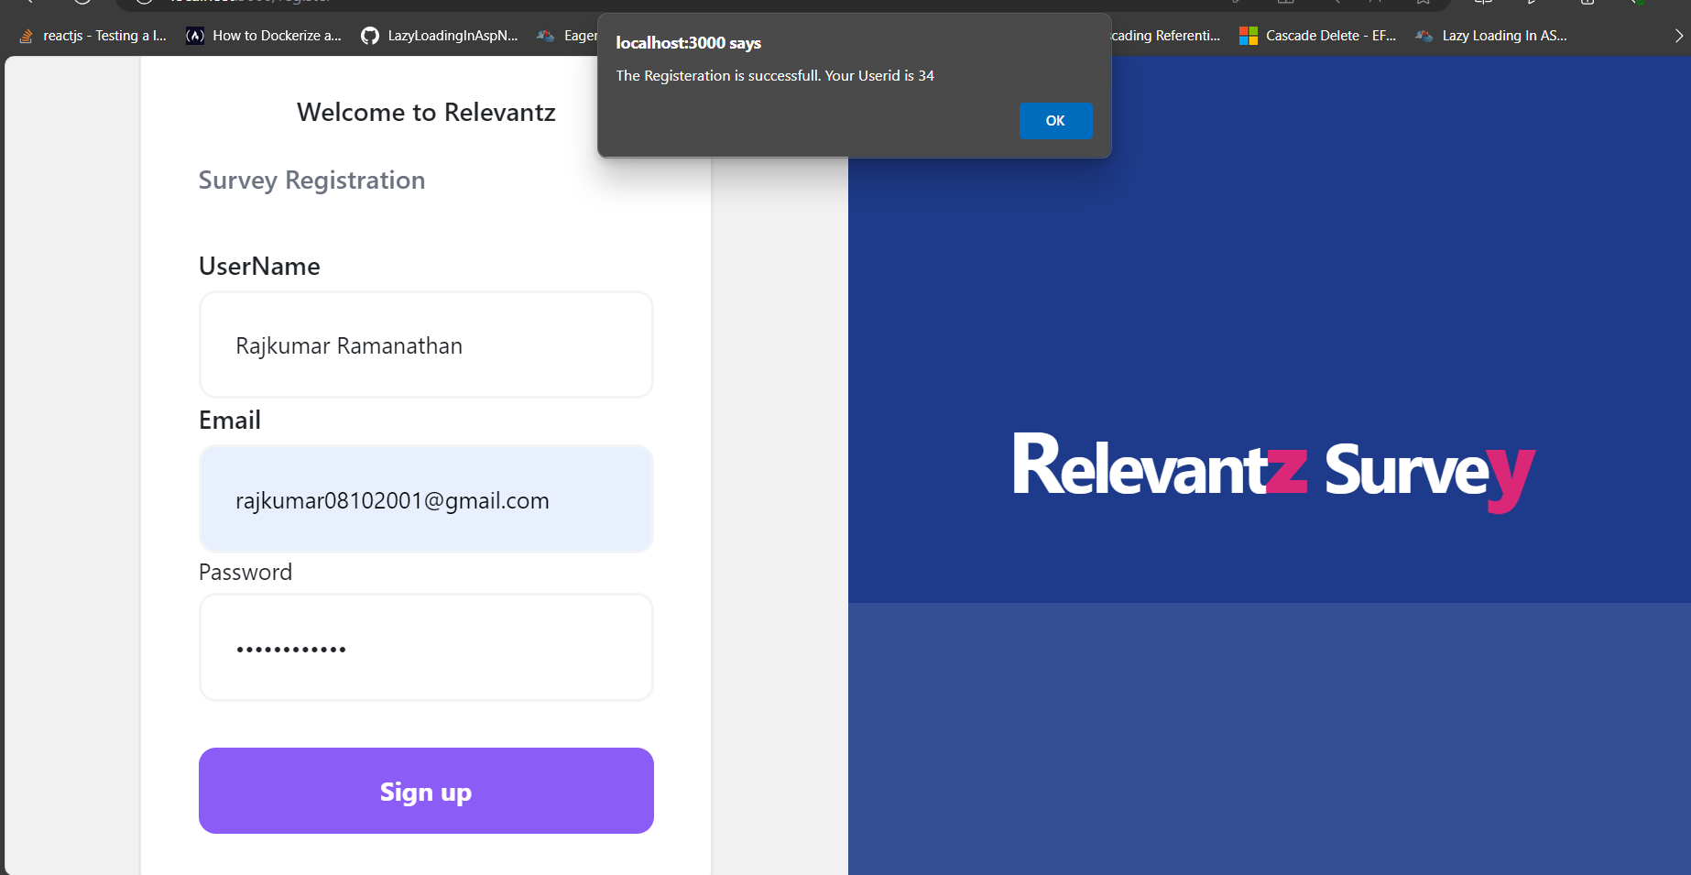  
  
  
2.Login Page

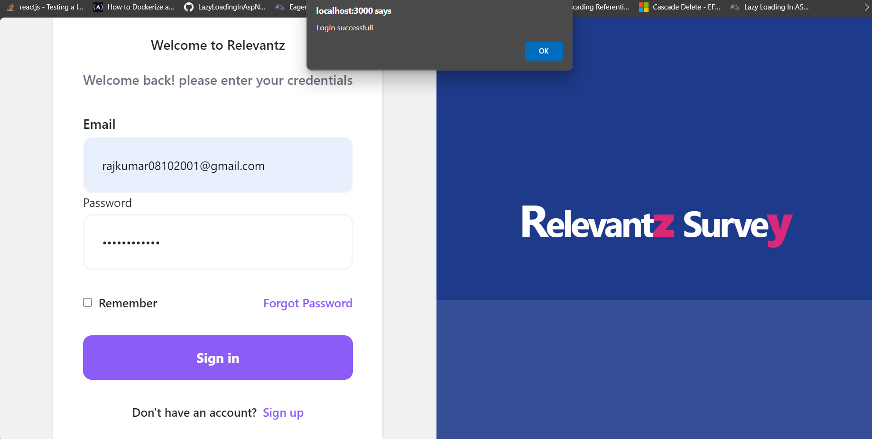

3.Home page  


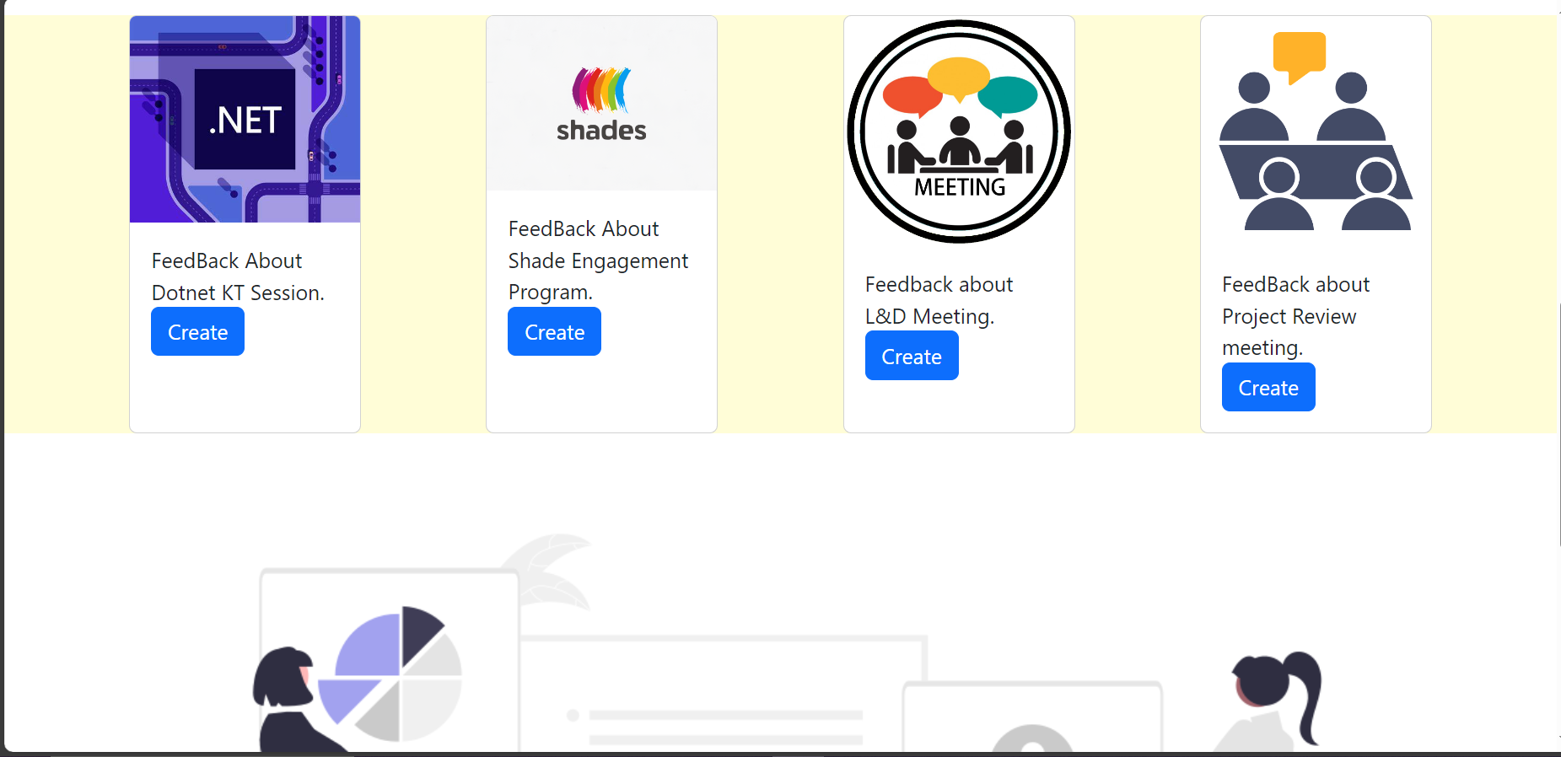

4.Creating a Survey

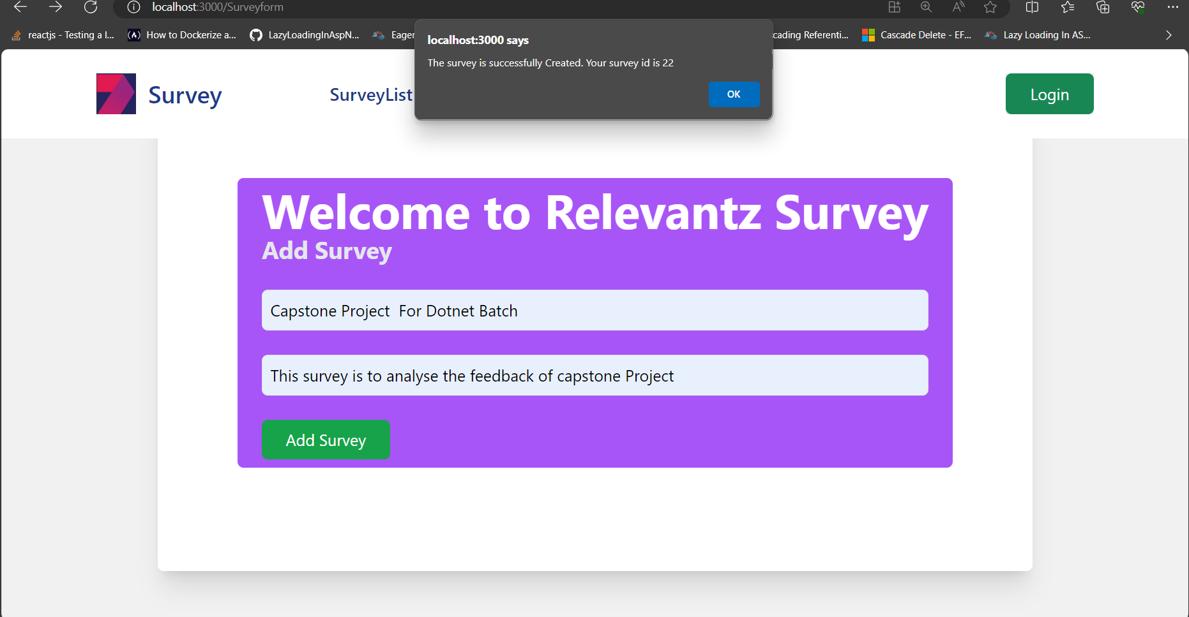

5.Add Questions to Survey

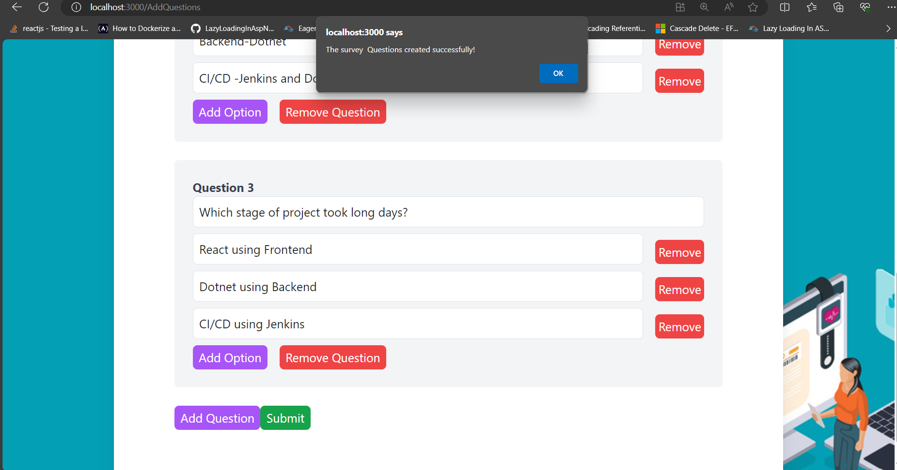

6.View Added Question in user Dashboard:

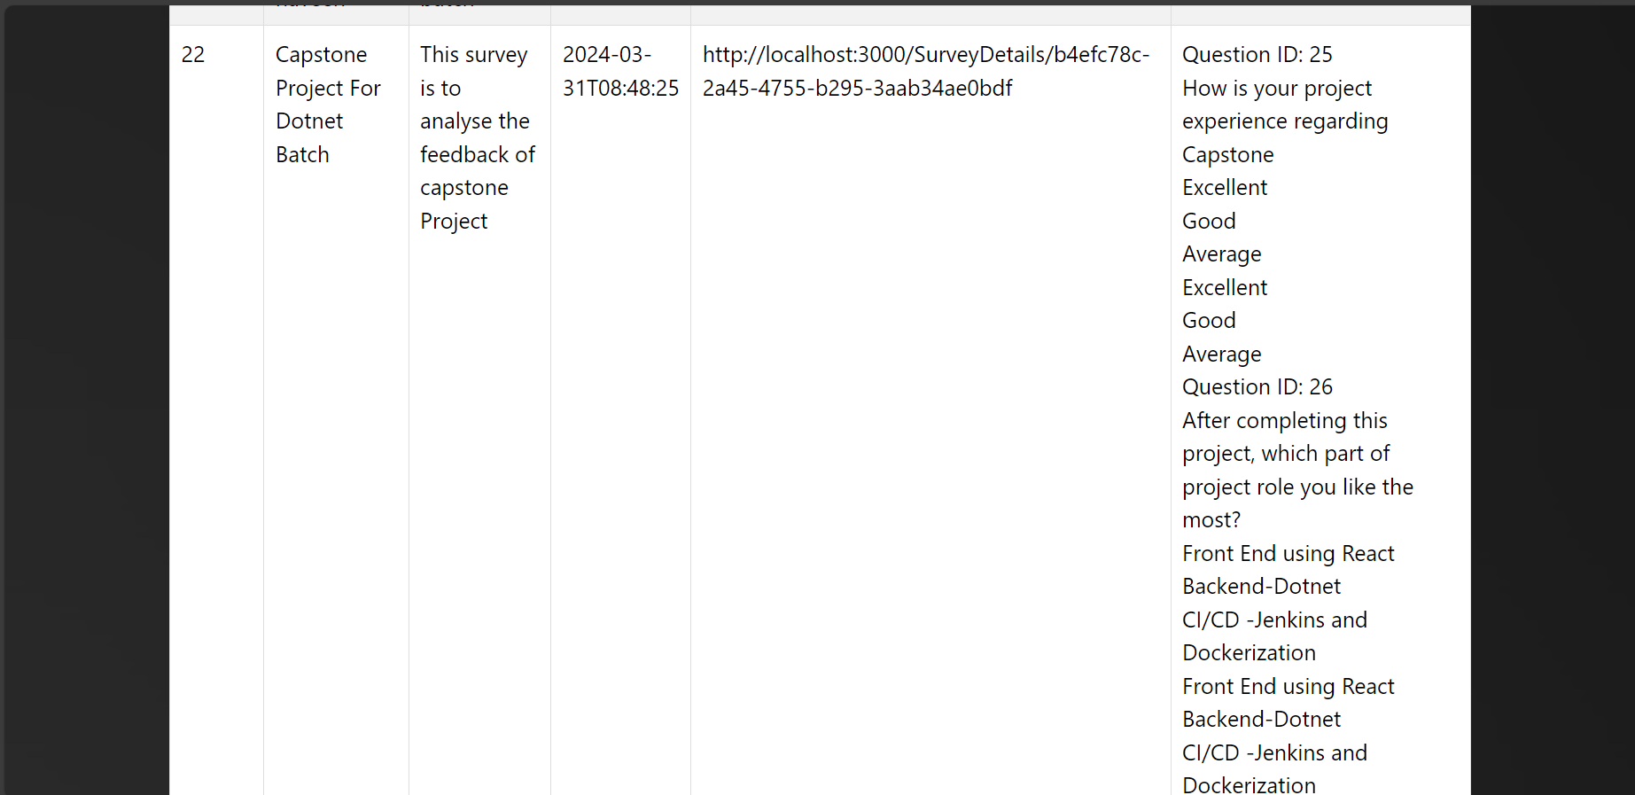

7.Take a Survey and add responses

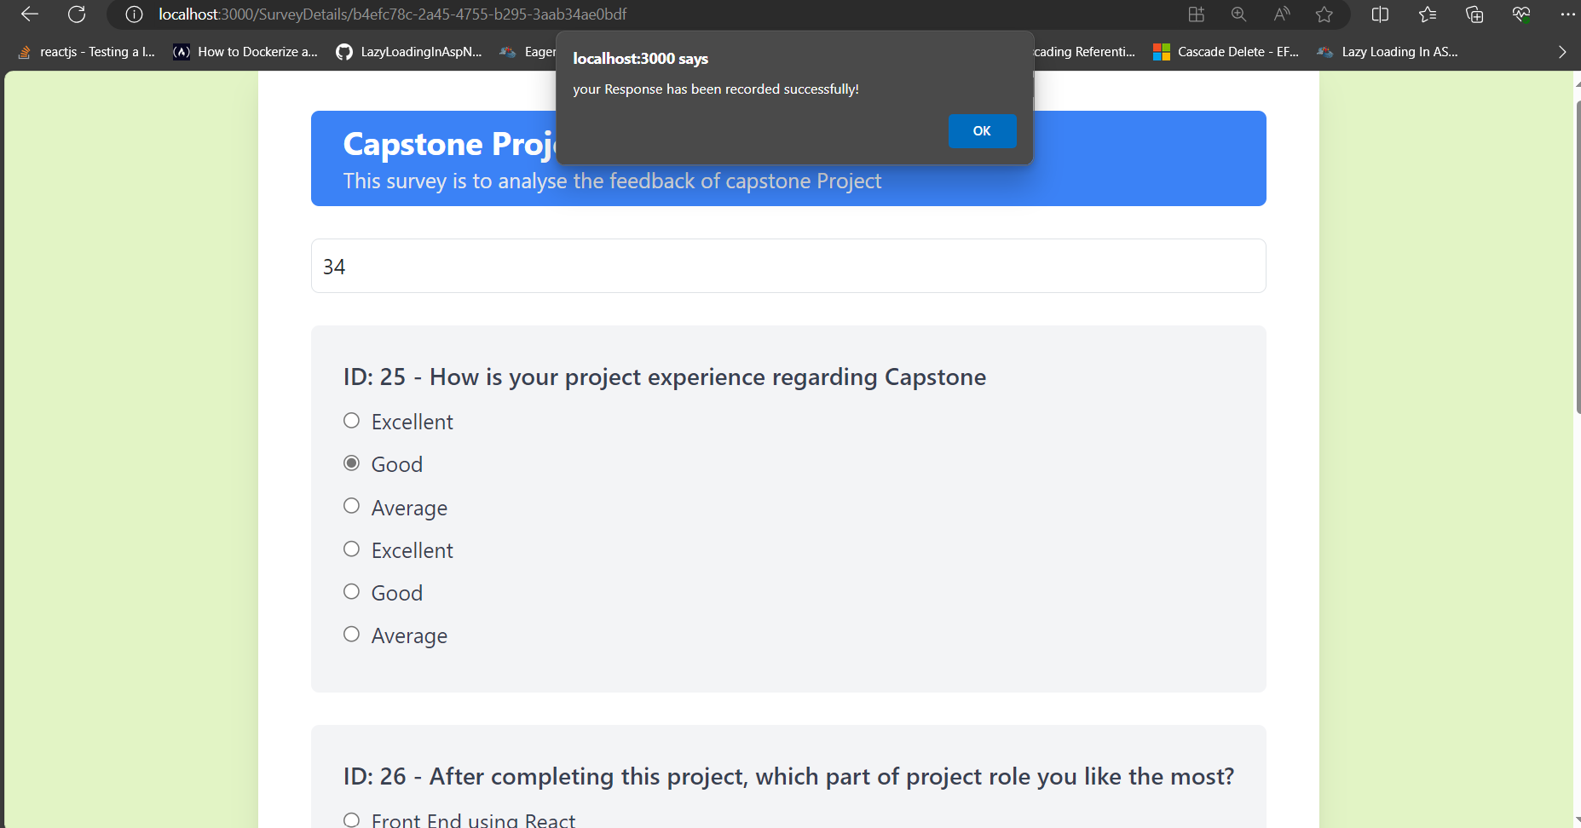

8. Survey Analysis Dashboard from User responses

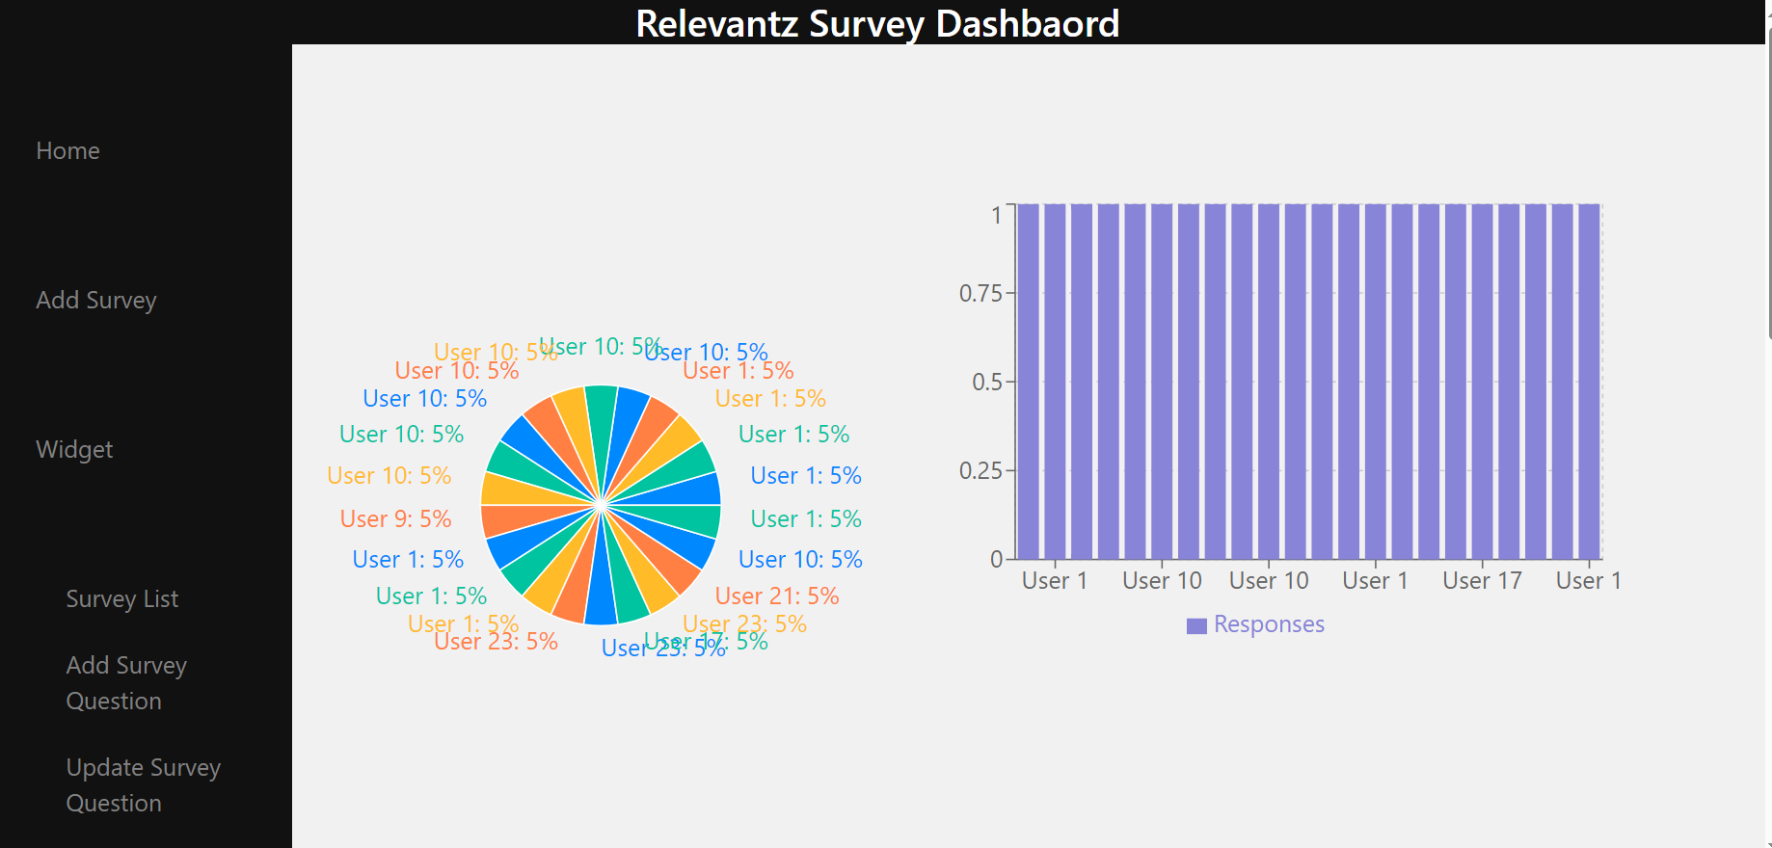

**Database Tables:**

Survey Creation Table

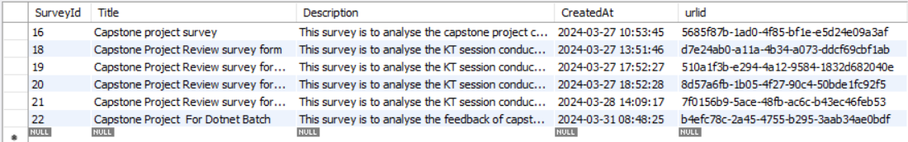

Question table

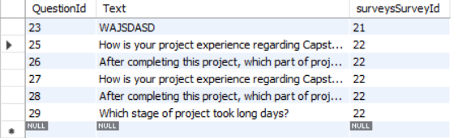

Options Table

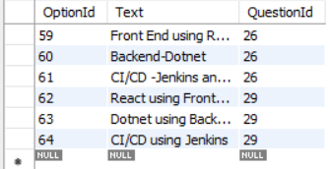

Responses Table

